Pre-K IB Inquirer
Home Sweet Home- Unit 2
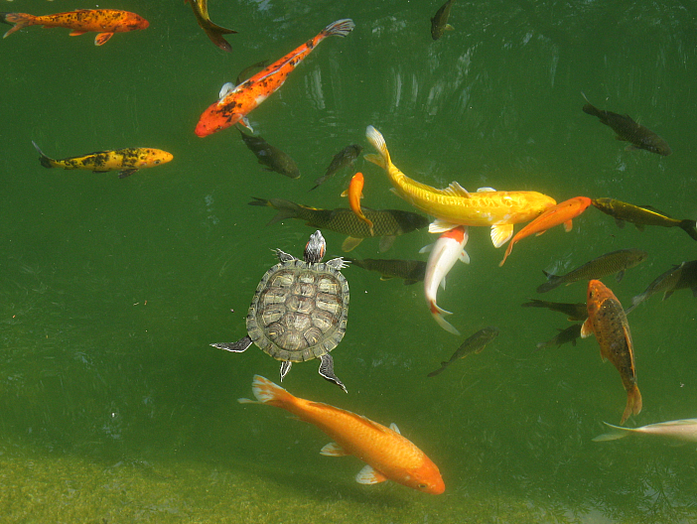

Transdisciplinary Theme:
SHARING THE PLANET: An inquiry into communities and the relationships within and between them.

Central Idea:
Our personal perspectives can change our environment.
A study into (lines of inquiry):
- An inquiry into living and non-living things’ basic needs, habitats, and life cycles.
- An inquiry into how people impact the environment in a positive and negative way
- An inquiry into how living and non-living things impact the world

Student Final Project:
Students imagine that they are building an ecosystem for a plant or animal of their choosing. They will use real and found materials to represent the ecosystem in an artistic format, and share with their classroom and teachers their understanding of the needs of the plant/animal selected.

Technology Tie-In:
- Students will utilize online websites and apps to research life cycles, habitats, and recycling: Brainpopjr.com Reduce, Reuse, Recycle, Peppa Pig learning related composting videos, Skype with Zoo or Aquarium

Field Experiences:
- Students will create ecosystem for beta fish, turtle, or frog in the classroom.
- Students will visit the Science lab to discover life cycles of a plant and animal, and learn about reduce, reuse, recycling as an impact on the environment.
- Visit the School garden and Invite Nature Center staff to join class

Learner Profiles:
- Reflective: Students will learn how to reflect on their own completed work
- Knowledgeable: Students will gather knowledge and share information with peers

Attitudes:
- Cooperation
- Confidence
- Curiosity
- Creativity

Key Concepts:
- Function – how do living and non-living things work together to create an environment
- Causation- how do we affect the environment
- Change- how do living things change over time

Approaches to Learning:
Students will use their:
- Communication skills to listen, speak, and write to share information
- Self-Management skills to take care of and have control over their bodies
- Research skills to show interest and determination to learn new information

I.B. AT HOME
Name ______________________

Parents: please fill out any that apply and return to your child’s teacher at the end of the unit (week of November 7th).

My child is displaying the learner profiles from his/her IB unit (reflective and knowledgeable). Here are some examples:
_______________________________________________________________________________________________________________________________________________________________________________________
Here is how my child is showing the IB attitudes (Cooperation, Confidence, Curiosity, and Creativity):
_______________________________________________________________________________________________________________________________________________________________________________________
My child has been demonstrating the approaches to learning (communication, self-management, and research) by:
_______________________________________________________________________________________________________________________________________________________________________________________
My child has taken action (additional investigations, trying to make a difference, reading more about the subject, doing an independent project, teaching others, etc.) regarding this unit. Here’s how:
___________________________________________________________________________________________________________________________________________________________________________________________________________________________________________________________________________________________________________________________________________________________________________________________________________________________________________

IB Elements that Pre-Kindergarteners are focusing on during Unit 2/Sharing the Planet

